University of Central Punjab
Faculty of Information Technology and Computer Science
Course Title: Human Computer Interaction Course Code: SESE 2123

Assignment 4
Date: 08-01-2025
Name | Registration Number | Section
Muhammad Arham | L1F23BSSE0372 | SE-E6
Aswad Khan | L1F23BSSE0328 | SE-E6
Zohaib Ali | L1F23BSSE0326
Total Marks 60
CLO # | Course Learning Outcome (CLO) | Taxonomy Level | Mapping to PLO
CLO 3 | Design innovative solutions to real-world Human-Computer Interaction challenges, and employ a range of design evaluation techniques to assess and refine the designs for enhanced Usability . | C3 | PLO 4

Instructions:
- Attempt all questions.
- Group Member Allowed (Project Group Members)
- Assignment should be handwritten and submitted on A4 sheets or Assignment sheets only. Violation will result to deduction of 5 marks from the scored marks.
- Each group is supposed to attach this front page with his/her assignment. Violation will result to deduction of 5 marks from the scored marks.
- Due Date for Assignment (Soft Copy) is January 14, 2025 10:00 PM (Portal).
- Due Date for Assignment (Hard Copy) is January 15,2025
- Late submission will result in 10% deduction.
- No request for late submissions will be considered after two working days of the deadline.
- No request to review assignment will be considered after 3 working days of the review in class.
- Project Name
University Smart Cafe
- Evaluator Name(s)
Muhammad Arham | Aswad Khan | Zohaib Ali

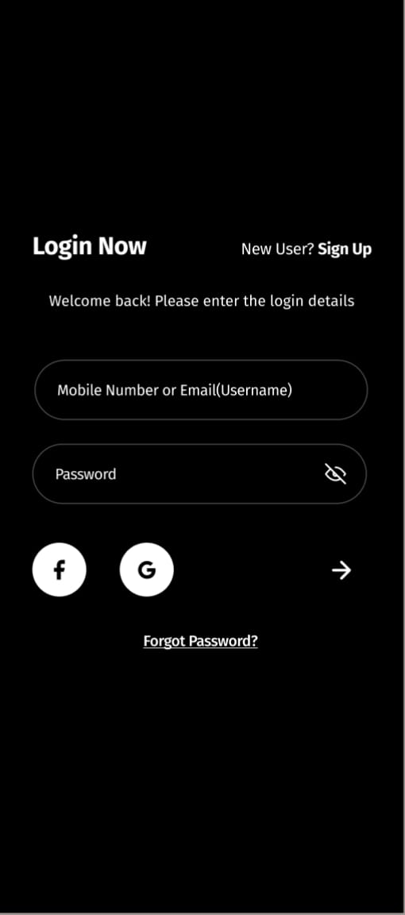
Screen 1: Login Screen

Negative Application of Heuristics
Sr No | Usability Problem | Severity | Suggestion | Heuristic Violated
1 | No error message for wrong login | 3 | Show “Invalid username or password” | Visibility of system status
2 | Password rules not shown | 2 | Show password requirements | Error prevention
3 | Social icons not labeled | 1 | Add text under icons | Match between system & real world

Positive Application of Heuristics
Sr No | Heuristic | Comments
1 | Consistency and standards | Same style input fields
2 | User control and freedom | Forgot password option

Screen 2: Sign Up Screen
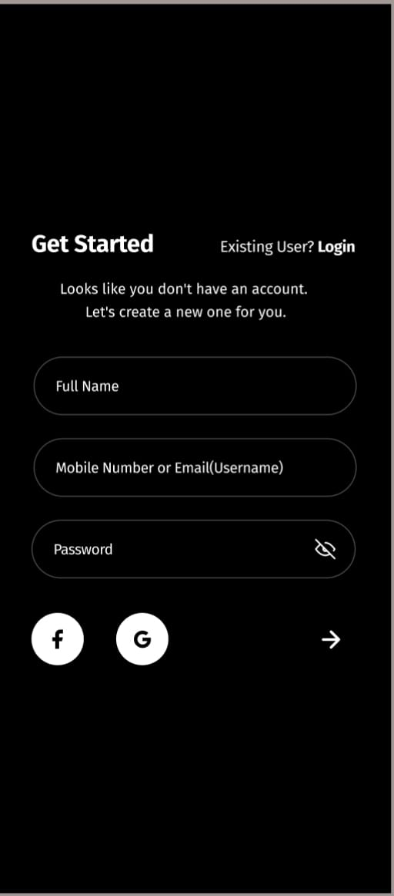

Negative Application of Heuristics
Sr No | Usability Problem | Severity | Suggestion | Heuristic Violated
1 | No success message after sign up | 2 | Show confirmation message | Feedback
2 | Username format not explained | 1 | Show example username | Help & documentation
3 | Password strength not shown | 2 | Add password strength indicator | Error prevention

Positive Application Of Heuristics
Sr No | Heuristic | Comments
1 | Aesthetic and minimalist design | Simple form layout
2 | Match with real world | Clear field labels

Screen 3: Settings Screen
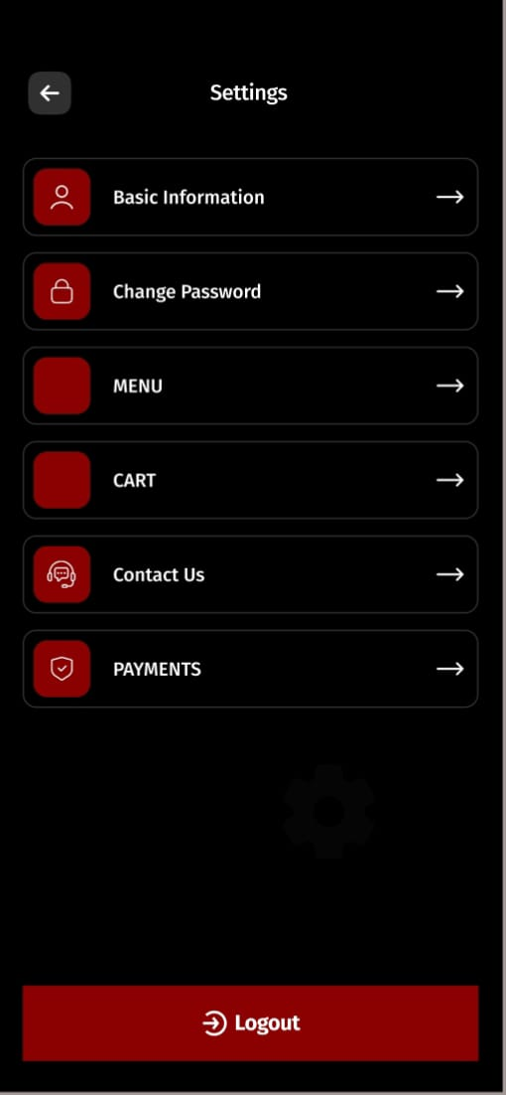

Negative Application of Heuristics
Sr No | Usability Problem | Severity | Suggestion | Heuristic Violated
1 | MENU and CART inside settings | 2 | Move to main navigation | Match with real world
2 | No description for options | 1 | Add short explanations | Help & documentation
3 | Icons not clearly explained | 1 | Add text labels | Recognition rather than recall

Positive Application of Heuristics
Sr No | Heuristic | Comments
1 | User control and freedom | Logout option available
2 | Consistency | Same card layout used

Screen 4: Menu Screen
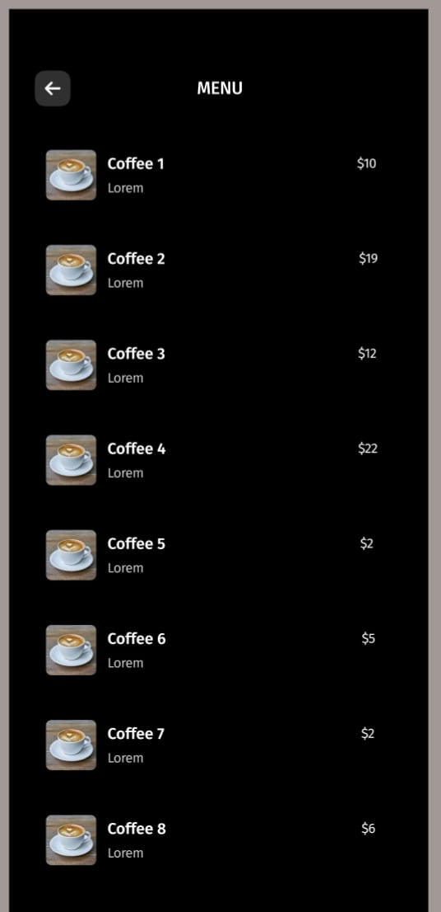

Negative Application of Heuristics
Sr No | Usability Problem | Severity | Suggestion | Heuristic Violated
1 | No filter or category option | 1 | Add category filters | Flexibility & efficiency
2 | Short item description | 1 | Add more details | Help & documentation
3 | No add-to-cart confirmation | 2 | Show toast message | Feedback

Positive Application of Heuristics
Sr No | Heuristic | Comments
1 | Recognition rather than recall | Images help selection
2 | Visibility of system status | Prices shown clearly

Screen 5: Custom Message Screen
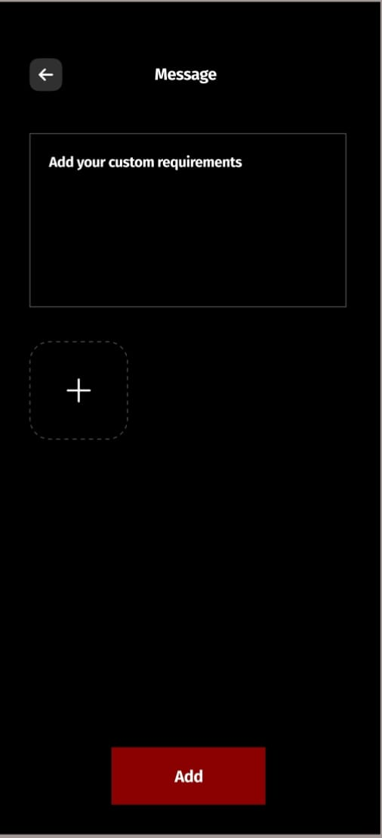

Negative Application of Heuristics
Sr No | Usability Problem | Severity | Suggestion | Heuristic Violated
1 | “+” button unclear | 2 | Add label or tooltip | Match with real world
2 | No character limit shown | 1 | Show text limit | Error prevention
3 | No confirmation on add | 2 | Show success message | Feedback

Positive Application of Heuristics
Sr No | Heuristic | Comments
1 | User control and freedom | Custom text allowed
2 | Minimalist design | Simple layout

Screen 6: Cart Screen
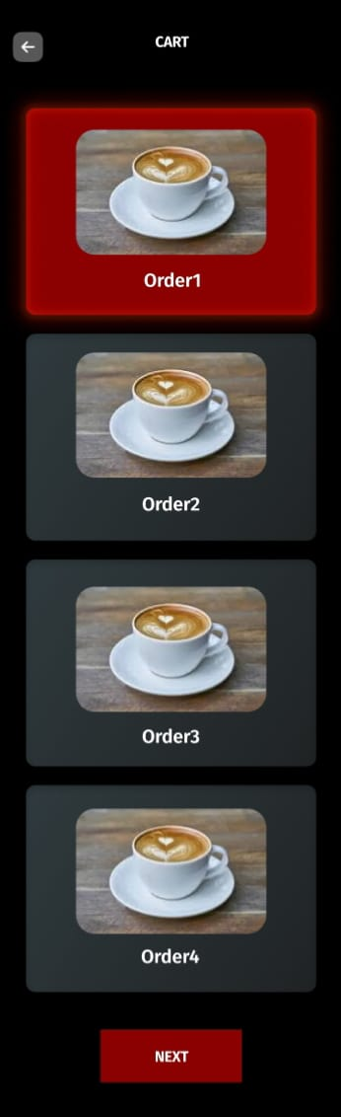

Negative Application of Heuristics
Sr No | Usability Problem | Severity | Suggestion | Heuristic Violated
1 | Cannot change quantity | 3 | Add + / − buttons | User control & freedom
2 | Total price not shown | 2 | Display total amount | Visibility of system status
3 | Remove item option missing | 2 | Add remove button | User control & freedom

Positive Application of Heuristics
Sr No | Heuristic | Comments
1 | Feedback | Selected item highlighted
2 | Consistency | Same card style

Screen 7: Payment Screen
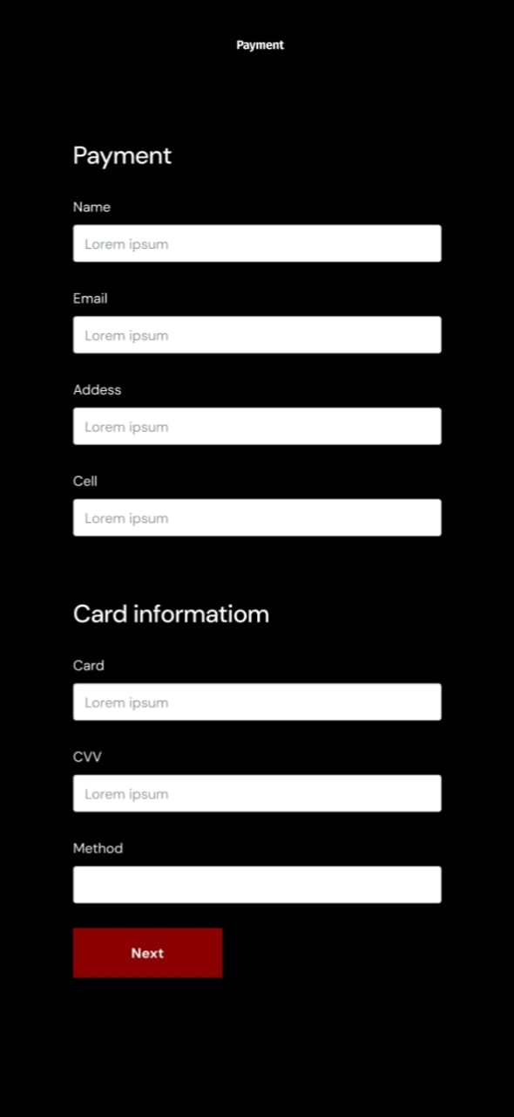

Negative Application of Heuristics
Sr No | Usability Problem | Severity | Suggestion | Heuristic Violated
1 | Card format not shown | 3 | Show card format example | Error prevention
2 | CVV explanation missing | 2 | Add help text | Help & documentation
3 | Payment method unclear | 2 | Show selectable options | Match with real world

Positive Application of Heuristics
Sr No | Heuristic | Comments
1 | Match with real world | Logical payment flow
2 | Visibility of system status | Clear Next button

Screen 8: Reward Screen
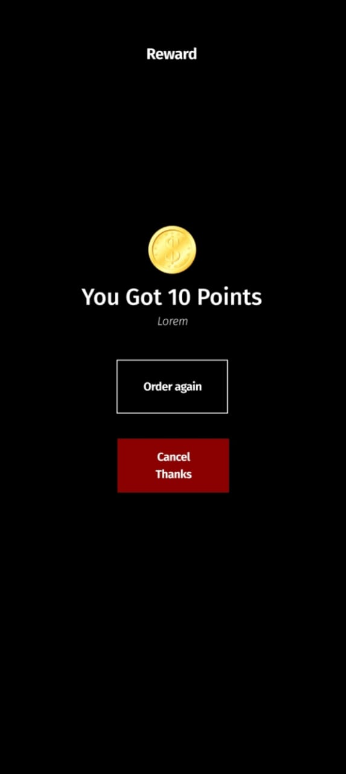

Negative Application of Heuristics
Sr No | Usability Problem | Severity | Suggestion | Heuristic Violated
1 | Reward system not explained | 1 | Explain points usage | Help & documentation
2 | Cancel button unclear | 1 | Rename button | Match with real world
3 | No history of rewards | 1 | Show reward history | Flexibility & efficiency

Positive Application of Heuristics
Sr No | Heuristic | Comments
1 | Feedback | Points clearly displayed
2 | Minimalist design | Focus on reward

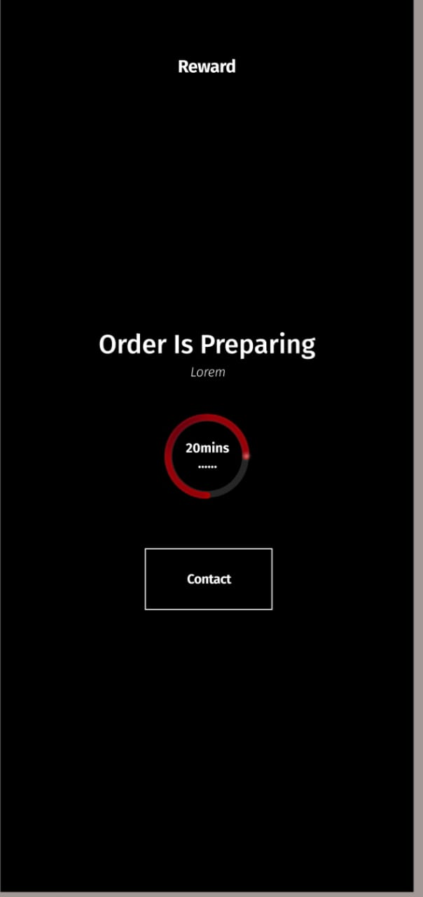
Screen 9: Order Preparing Screen

Negative Application of Heuristics
Sr No | Usability Problem | Severity | Suggestion | Heuristic Violated
1 | No detailed order status | 2 | Show steps (preparing, ready) | Visibility of system status
2 | Contact button unclear | 1 | Specify contact purpose | Help & documentation
3 | No cancel option | 2 | Add cancel order option | User control & freedom

Positive Application of Heuristics
Sr No | Heuristic | Comments
1 | Feedback | Countdown timer
2 | Match with real world | Order preparing message

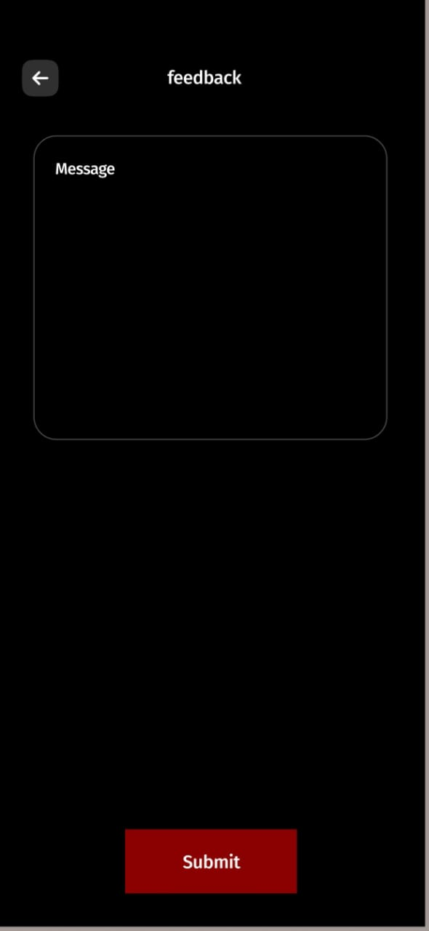
Screen 10: Feedback Screen

Negative Application of Heuristics
Sr No | Usability Problem | Severity | Suggestion | Heuristic Violated
1 | No rating option | 2 | Add star rating | Flexibility & efficiency
2 | No confirmation message | 2 | Show thank you message | Visibility of system status
3 | Feedback is optional but unclear | 2 | Add helper text | Help & documentation

Positive Application of Heuristics
Sr No | Heuristic | Comments
1 | User control and freedom | Free text feedback
2 | Minimalist design | Clean interface

Task 1: User Login
Task Description:
User wants to log in to the app using email and password.
Questions / UA’s | UA1 | UA2 | UA3 | UA4
Will users see that the action is available? | Yes, login fields are visible | Yes, password field is visible | Yes, login button is visible | Yes
Once users have found the correct action, will they know it is the one they need? | Yes, email field is labeled | Yes, password field is clear | Yes, button says login | Yes
Is the effect of the action the same as the user’s goal at that point? | Yes | Yes | Yes | Yes
After the action is taken, will users understand the feedback they get? | Yes | Yes | Partially (no error message) | Partially

Task 2: Create a New Account (Sign Up)
Task Description:
User wants to create a new account.
Questions / UA’s | UA1 | UA2 | UA3 | UA4
Will users see that the action is available? | Yes, sign up option is visible | Yes | Yes | Yes
Once users have found the correct action, will they know it is the one they need? | Yes, labeled fields | Yes | Yes | Yes
Is the effect of the action the same as the user’s goal at that point? | Yes | Yes | Yes | Yes
After the action is taken, will users understand the feedback they get? | No confirmation shown | No | No | No

Task 3: Add Coffee to Cart
Task Description:
User wants to select a coffee and add it to cart.
Questions / UA’s | UA1 | UA2 | UA3 | UA4
Will users see that the action is available? | Yes, items are visible | Yes | Yes | Yes
Once users have found the correct action, will they know it is the one they need? | Yes, item image helps | Yes | Yes | Yes
Is the effect of the action the same as the user’s goal at that point? | Yes | Yes | Yes | Yes
After the action is taken, will users understand the feedback they get? | No clear add-to-cart message | No | No | No

Task 4: Make Payment
Task Description:
User wants to enter card details and complete payment.
Questions / UA’s | UA1 | UA2 | UA3 | UA4
Will users see that the action is available? | Yes, payment form visible | Yes | Yes | Yes
Once users have found the correct action, will they know it is the one they need? | Yes, labeled fields | Yes | Yes | Yes
Is the effect of the action the same as the user’s goal at that point? | Yes | Yes | Yes | Yes
After the action is taken, will users understand the feedback they get? | No success message | No | No | No

Task 5: Give Feedback
Task Description:
User wants to submit feedback after order completion.
Questions / UA’s | UA1 | UA2 | UA3 | UA4
Will users see that the action is available? | Yes, feedback screen visible | Yes | Yes | Yes
Once users have found the correct action, will they know it is the one they need? | Yes, message box clear | Yes | Yes | Yes
Is the effect of the action the same as the user’s goal at that point? | Yes | Yes | Yes | Yes
After the action is taken, will users understand the feedback they get? | No confirmation shown | No | No | No

